# **Click Clack**

### Doing nothing

Zoe's avatar

[Zoe](https://substack.com/@zoeffc)

Mar 28, 2025

4

[1](https://femmefuturescooperative.substack.com/p/click-clack/comments)

1

Share

Hi friends,

I have a confession: going click-clack on my computer for however many hours a day, five days a week, feels dumb when it seems like the world is falling apart.

*Does it matter? What does it mean to do something that matters? What else can I do? What should I do? Is this just a phase? But I love my job… why doesn’t it feel fulfilling right now?*

This week, I want to ramble around the existential cloud that has settled over me this week. For many of us, we want to have an impact on the world around us, so I know this particular spiral is familiar, and I want to talk about it.

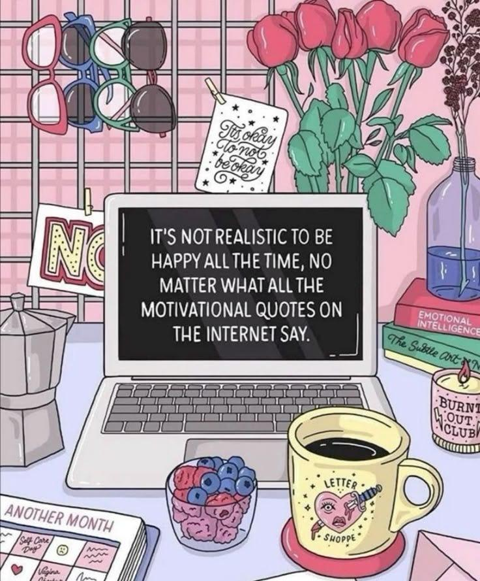

artist unknown

Before I go any further — let’s do the housekeeping.

First, if you are not already a subscriber and you resonate with any of the following descriptors, consider joining the cooperative: (1)Early-career professional; (2) Feminist; (3) Do-gooder; (4) Former Gifted Kid; (5) Overachiever; or (6) Capitalism-hater.

Subscribed

Second, if you like what I am saying and it makes you think of someone in your family/office/friend group, send it their way.

[Share Femme Futures Cooperative](https://femmefuturescooperative.substack.com/?utm_source=substack&utm_medium=email&utm_content=share&action=share)

Third, I say some personal and vulnerable shit every week. Say some vulnerable shit back. It’s called a community.

[Leave a comment](https://femmefuturescooperative.substack.com/p/click-clack/comments)

Okay — back to it.

Today, as I pulled into my work parking lot and made my way over to my little cubicle, I felt the optimism drain out of me.

My job is highly project-focused and for the first three months of the year, I was neck-deep in my projects. Each day, I had things that I needed to do to pull off these projects. I felt purposeful. I knew that if I wasn’t on top of each task and element, there would be a wrench in the final product and that would reflect on me. I finished both projects with pizzazz and a ton of compliments. That felt good.

Now I am between major deadlines and have to go out looking for projects or work on my back-burner projects. I have a couple of important ongoing tasks, but they rely on other people with other timelines and truthfully, they aren’t insanely urgent. So here I am, floating. When motivation strikes, I float in one direction for a while, then I hit a block. Sometimes that block is practical, like another person or system that I have to wait on. Sometimes that block is emotional, “does this matter? will anyone actually care if I don’t do this? will anyone make use of this if I do?”

One benefit of this type of work is that I get to listen to podcasts. I put on my big, noise-cancelling headphones, and lock in. I’ve listened to some good ones lately — but yesterday the Houthi PC Small Group chat news dropped and I got obsessed.

Remember when I promised to not start my day be listening to the news because it is bad for me? I reflected on the challenge of that in my Substack notes:

Zoe's avatar

[ZoeMar 13](https://substack.com/@zoeffc/note/c-100153248)

[A few weeks ago I wrote this article about running away from the American news media. Today, I slipped on my resolution not to start the day with news and it freaked me out how much I’d missed.](https://substack.com/@zoeffc/note/c-100153248)

[Here’s my thought process: news about things like the Department of Education, or even the stock market and its inevitable impact on everyday peop…](https://substack.com/@zoeffc/note/c-100153248)

[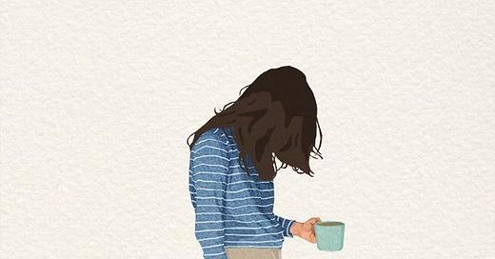](https://substack.com/@zoeffc/note/c-100153248)

[Femme Futures Cooperative](https://substack.com/@zoeffc/note/c-100153248)

[Femme Futures Cooperative](https://substack.com/@zoeffc/note/c-100153248)

[Reading to Escape the News](https://substack.com/@zoeffc/note/c-100153248)

I have been getting lax with this rule for myself, and yesterday, when the Atlantic broke the story, I listened to that podcast before my alarm even went off, letting it soak into my half-awake brain.

This story (then and as it continues to unfold) is emblematic of the state of the US right now. It’s terrifying. Add that to the fact that spending cuts are impacting my industry indirectly and we are recession-proofing as an organization. *[A topic for another time is how this is many of our first times going through this level of economic instability and it is scary as shit.]*

So there I am. My world is a shaky piece of paper sat on the back of a turtle sat on the back of a turtle, sat on the back of a turtle. What do I do? I send emails. I sit in meetings. I do my back-burner projects. What *else* can I do?

Yeah, the dread is existential, but here’s the thing that I come back to: it doesn’t always feel like this. This week has been a perfect storm of stuff, and it’s true, I cannot impact global economic policy. But I have good days. I have days at work where the time flies by and at the end of the day, it is my team and I doing good work.

Plus, I am a whole *person* outside of work. I can nap in the sunshine and go for walks in the woods. I can cuddle with puppies and spend hours talking with my friends over drinks.

The click-clack sucks sometimes. But sometimes it doesn’t. Even when it does suck though, it is only a part of my life.

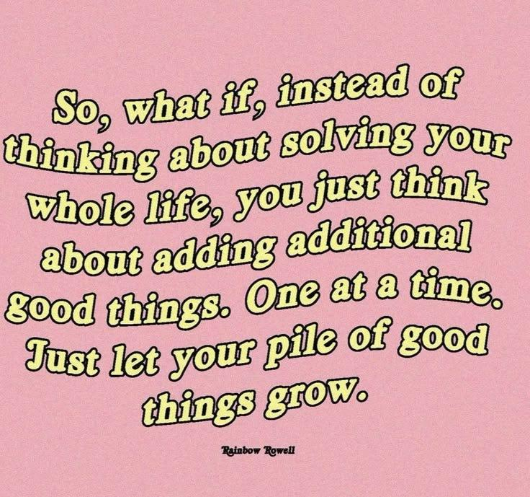

What I am hoping you guys take away from this:

* the world is a mess and it is okay if that gets to you sometimes — it gets to me.
* your work might not be changing the world. This country is a car careening around mountain roads with a toddler at the wheel and a clown in the passenger seat. No one’s work can ensure our safe outcome right now.
* sometimes work is fulfilling, sometimes it is draining — remember that there is more to you than your job.

What did you actually take away from it?

Best,

Zoe